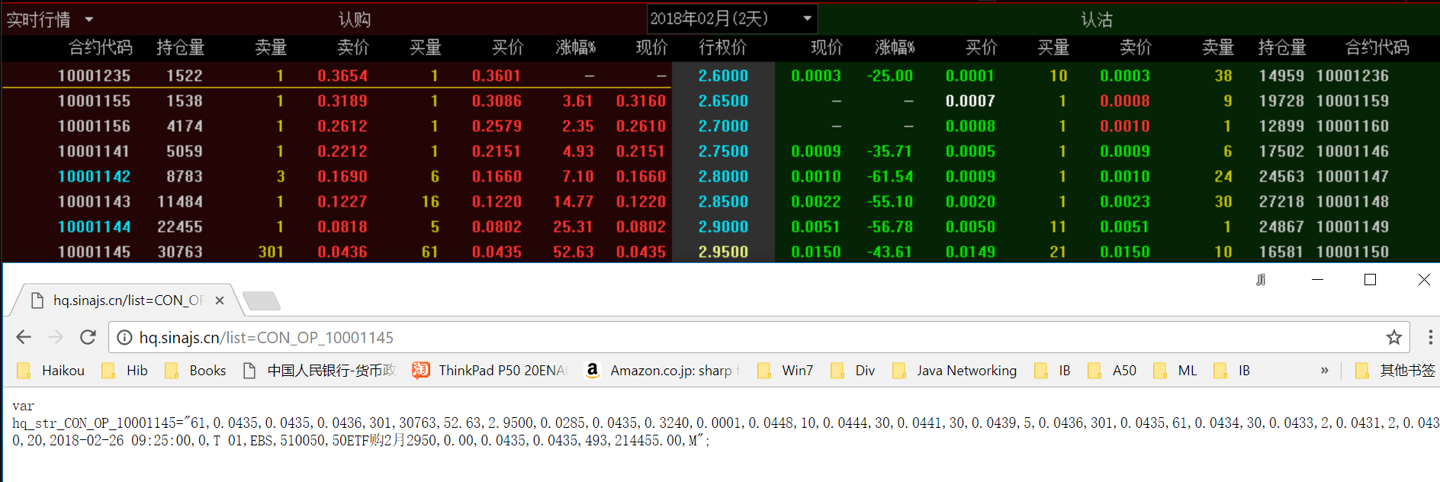

Name, buy size, buy price, last price, sell price,